**535/2**

**PHYSICS**

Paper 2

Jul/Aug 2019

2 ¼ Hours



**MUKONO EXAMINATION COUNCIL**

**Uganda Certificate of Education**

**PHYSICS**

Paper 2

2 Hours 15 Minutes

**INSTRUCTIONS TO CANDIDATES:**

*Answer any* ***five*** *questions.*

*Any additional question(s) answered will* ***not*** *be marked.*

*Mathematical tables and silent non-programmable calculators may be used.*

*These values of physical quantities may be useful to you:*

*Acceleration due to gravity 10 ms-2.*

*Specific heat capacity of water 4200 Jkg-1K-1.*

*Specific heat capacity of copper 400 Jkg-1K-1.*

*Specific latent heat of fusion of water 340000 Jkg-1.*

*Speed of sound in air 320 ms-1.*

*Velocity of electromagnetic waves 3.0 X 108 ms-1.*

1. (a)(i) State Pascal’s principle. ***(1mark)***

(ii)In an experiment to measure the pressure of a gas supply, a U-tube manometer is connected to a gas cylinder as shown in the figure below. The length, h of the mercury column is 18cm and atmospheric pressure is 760mmHg.

Find the pressure of the gas.  ***(3marks)***

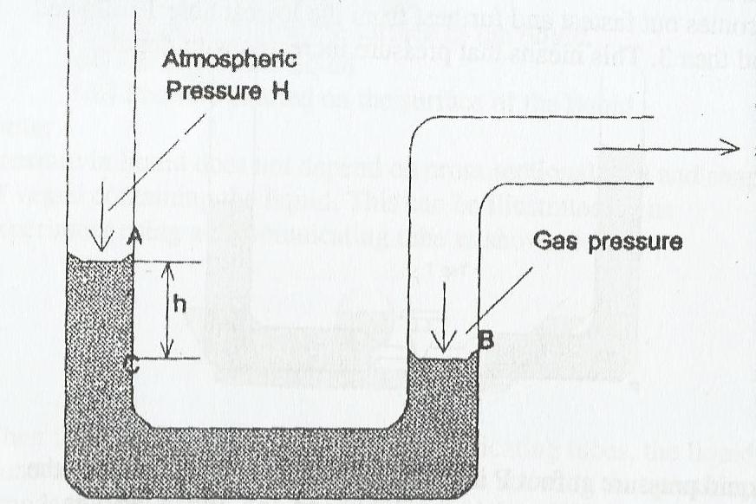

(b) Explain what happens when an inflated balloon is released in air. ***(2marks)***

(c)(i) Describe with the aid of a labelled diagram, how a force pump works. ***(4marks)***

(ii) State one application of atmospheric pressure.  ***(1mark)***

(d)(i) State the law of conservation of energy. ***(1mark)***

(ii) A stone of mass 0.2kg is thrown vertically upwards attaining a maximum potential energy of 16J. Calculate its initial velocity. ***(4marks)***

2(a). State the laws of refraction of light. ***(2marks)***

(b) Describe an experiment to determine the focal length of a convex lens using a plane mirror.  *(4marks)*

(c) Define the following:

(i) Refractive index of a material.  ***(1mark)***

(ii) Critical angle. ***(1mark)***

(d) Calculate the critical angle for a water-glass boundary if the refractive index of water is 1.4

while that of glass is 1.52 ***(2marks)***

(e)(i) State **two** applications of total internal reflection. ***(2marks)***

(ii) Draw a ray diagram to show how a convex lens forms a virtual, magnified image of a real

object. ***(2marks)***

(f) A convex lens produces a real image magnified four times of an object placed 5cm from the

lens. Determine focal length of this lens. ***(2marks)***

3. (a) Define the following terms as applied to waves:

(i) Wavelength. ***(1mark)***

(ii) Amplitude.  ***(1mark)***

(iii) Wave front. ***(1mark)***

(b)(i) Distinguish between longitudinal and transverse waves.  ***(2marks)***

(ii) List **three** differences between sound waves and light waves. ***(3marks)***

(c)(i) Define resonance as applied to sound waves.  ***(1mark)***

(ii) Describe how the speed of sound in air is determined using a resonance tube. ***(4marks)***

(iii) Explain why an open tube is preferred as an musical instrument than a closed tube.

***(1mark)***

(d) A man standing midway between two cliffs makes a loud sound and hears the first echo after 3 s, Calculate the distance between the cliffs. ***(2marks)***

4. (a) Define acceleration due to gravity and state its SI unit.  ***(2marks)***

(b) The diagram below shows a section of a tape obtained when pulled by a trolley through a ticker timer vibrating at 40Hz. Use the diagram to explain how the acceleration of the trolley may be obtained. ***(3marks)***

6cm 3cm

Direction of motion.

(c) Sketch the velocity-time graph for the motion of the trolley in (b) above. ***(2marks)***

(d)(i) State the principle of conservation of momentum and explain its application. ***(2marks)***

(ii) Distinguish between elastic and inelastic collisions.  ***(2marks)***

(c) A body of mass 500g moving at 40ms-1 collides with another stationary body of mass 1000g placed on a smooth horizontal surface. If the bodies move together after collision, calculate the

(i) Common velocity of the two bodies after collision. ***(2½marks)***

(ii) Kinetic energy lost by the moving body. ***(2½marks)***

5. (a)(i) What is meant by strength of a material?  ***(1mark)***

(ii) State the factors that affect the strength of a material. ***(2marks)***

(b) A spring of natural length 5cm extends by 2mm when a force of 1.8N acts on it. Calculate the

extension when a force of 10N is applied to the spring. ***(2marks)***

(c) Give **four** reasons why bicycle frames are made of hollow cylindrical structures. ***(4marks)***

(d)(i) State the composition of reinforced concrete.  ***(2marks)***

(ii) Explain why the lower part of a ceiling of a building is made of reinforced concrete while the upper part is not reinforced. ***(3marks)***

(e) Explain how one can show that a beam on a building is a strut or tie. ***(2marks)***

6. (a) What is meant by the terms?

(i) Temperature? ***(1mark)***

(ii) Lower fixed point of a thermometer. ***(1mark)***

(b) Briefly describe an experiment to determine the lower fixed point of a thermometer. ***(4marks)***

(c) State **two** advantages and **two** disadvantages of using mercury as a thermometric liquid. ***(2marks)***

(d) Explain how the boiling point of a liquid depends on altitude.  ***(2marks)***

(e) A copper block of mass 100g is heated to 200°C and then quickly transferred to a copper calorimeter of mass 300g containing 400cm3 of water at 25°C.

(i) Calculate the maximum temperature attained by the water in the calorimeter. ***(3marks)***

(ii) Sketch the graph to show the variation of temperature with time.  ***(2marks)***

(iii) Explain **one** application of heat capacity. ***(1mark)***

7. (a)Define ***electromotive force*** of a cell.  ***(1mark)***

(b)Four resistors are connected across a 12V battery of negligible internal resistance as shown in the figure below.



A



3.0



3.0

Ω



2.0

Ω



4.0

Ω



V

12

(i) Determine the reading of the ammeter.  ***(2marks)***

(ii) The power dissipated by the 2Ω resistor. ***(1mark)***

(c) An electric appliance is rated 1200W, 240V.

(i) Explain what this statement means. ***(2marks)***

(ii) Calculate the cost of running this appliance for a week if it is used for 30 minutes each day, given that the cost of a unit of electricity is 500/=.  ***(3marks)***

(iii) Draw the magnetic field pattern due to an electric current in a solenoid through which a direct current is flowing. ***(2marks)***

(d) Describe how a lightning conductor works. ***(5marks)***

8. (a) What are X-rays?  ***(1mark)***

(b)(i) With the aid of a labelled diagram, describe how X-rays are produced in an X-ray tube. ***(5marks)***

(ii) State **one** medical use and **one** industrial use of X-rays.  ***(2marks)***

(c) Define the following:

(i) Nuclear fission.  ***(1mark)***

(ii) Nuclear fusion. ***(1mark)***

(d) A nuclide ${}_{92}^{235}W$ decays by emission of two alpha particles. The resulting nuclide emits three beta particles resulting into a nuclide, which emits gamma rays.

Determine the atomic mass and the number of protons of W and write a balanced equation for the decay. ***(3marks)***

(e)(i) What is meant by half-life of a radioactive substance? ***(1mark)***

(ii) The half-life of Radium is 1,620 years. How long will it take 16g of Radium to decay to 2g? ***(2marks)***

***END***